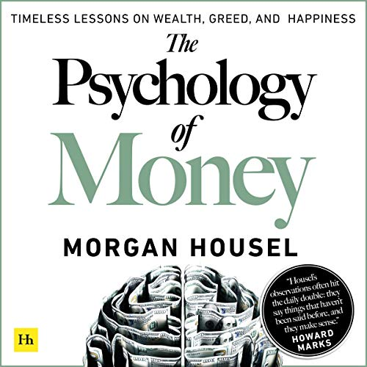

Why should you read ‘ The Psychology of Money’?

~ Shubham Rajput

As the saying goes, “Rome was not built in a day but Hiroshima was destroyed in a day”, this holds correct most of the time while we are making our financial decisions. What if someone had told you that the possibility of you getting wealthy is not a function of your income but it is a function of your behaviour? There is a good chance that you might not have believed him or her, if 1% of your personality resembles my behavioural patterns with respect to finances.

In India, the demography is getting more and more in favour of industrial expansion. Large population of the country is earning population, which means that the same population will be consuming population and as income will keep on increasing, so will be the consumption, and so will be the production of industries, and so will be the earnings due to increasing employment demand, and this cycle might keep on going.

Such kind of prospect brings us with two unique opportunities - first, more employment opportunities and continuous increase in earning due to skills and second, more opportunities to invest and save as industries will keep on growing and so will be their profits and so will be the share prices of those companies and so will be the returns on their investments had you invested.

And for every person, who wishes to invest his or her hard earned earnings in such kind of investment opportunities either through Mutual Funds or through direct investment, this book is a must read. This book will change your perception and will almost convince you that your future wealth(yes WEALTH not deposits) depends more on your behaviour and less on your income.

There are five key chapters that I would like to discuss and urge all of you who are either reading it on a blog or will be watching this on Youtube, to please go and read this book. So without any further delay, lets jump to those ***5 key chapters of total 20 chapters***  to give you a brief idea of the book -

**Lesson No. 1 - “Success is a lousy teacher. It seduces people into thinking that they can not lose”**

We often tend to forget or ignore or completely reject that every opportunity which came to us and transformed our lives was the outcome of luck playing in our favour. We tend to believe so much in ourselves that we can not fathom that a factor that can not be measured, can not be earned, can not be achieved, can have a role in our lives. The outcome we get when we ignore the part of luck in our success, be it financial or in terms of career, we start believing that there are no unknown factors that can not be controlled. And **that** expose us to another sibling of luck - **“risk”**.

This concept is conveyed in very simple terms. Bill Gates studied in the school which had early access to computers because the headmaster of the school was a World War-II veteran and he recognised the importance of computers. During those times, even many of the colleges didn’t get access to computers. What were the odds of you being in the place of Bill Gates? To get that opportunity, first you required the ***‘ovarian lottery’,*** that is you had to get birth during that time. Then you would have needed to be born in the USA and that too in the same school with the mindset of parents that you deserve good education and with a headmaster who would have been visionary enough to understand the importance of computers. And after so many coincidences, you would have got the chance to upgrade your skills to such an extent that you could went on to create world’s largest software company of the forthcoming century.

But Bill Gates was not the only one to get that kind of access. All his schoolmates got that access and only two of them went on to develop skills to a considerable level, one was of course Bill Gates and another was his friend. All others who did not develop such skills is a confirmation of the belief that hard work pays, but only when you are already rewarded with luck. Now, who was the friend of Bill Gates who developed the same kind of skills? His name was Kent Evans, and the reason you don’t know his name is that he died while mountaineering. That’s how risk is associated with luck.

What is the lesson we can learn? Always be prepared for every eventuality, positive or negative. Your every investment can earn you multiple returns on your investments (if luck is playing by your side) but the same can rob away all your money (if you fail to manage risk). Therefore risk management should be the essence of all your financial decisions, whether you are making investment decisions or you are a stock trader (especially if you are a stock trader). If luck comes in your favour you are earning a handsome return but if luck does not come your way, then at least you would have managed the risk.

Just imagine the condition of the person who has large amounts of loans - home loan, personal loans, business loans, credit card bills, etc. And out of nowhere, Covid-19 crisis evolved. Who would have thought of such a situation? Just imagine the plight of the person who failed to cover risk?

Lesson No. 2 on next write-up.

Page break image